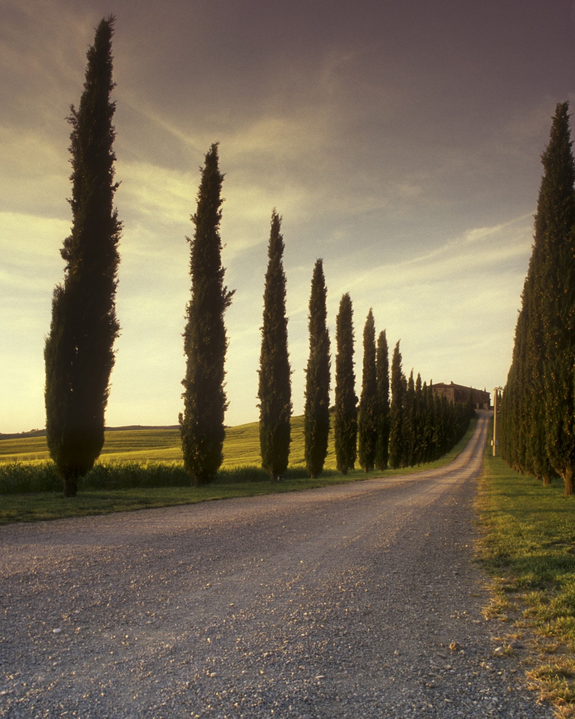 | The Outsiders  Read this story & answer all "Think" questions. Make sure you use citations when instructed to do so. I also added a story quiz as an optional assignment. After answering the “Think” questions, re-read the story & answer the “Focus” questions directly on the story pages.

Summary
In 1960s Middle America, members of a gang called The Greasers find Johnny, one of its members, badly beaten. In this excerpt, Ponyboy relates to Cherry how Johnny was accosted by four members of The Socs, an upper-class gang. Having grown up in a violent home, Johnny was used to aggression, but this beating changes him and he begins to carry a knife for protection. Cherry, a member of The Socs, explains that not all Socs would do such a thing. She also says that rich kids have problems just like everyone else. Ponyboy considers how much The Socs and The Greasers actually have in common and decides it’s money that separates them. Cherry disagrees because she thinks the two groups hold different values. The Socs are sophisticated and cold while The Greasers are emotional, which Cherry admires.

Excerpt from Chapter 2
1Start of paragraph 1 of 16We were used to seeing Johnny banged up—his father clobbered him around a lot, and although it made us madder than heck, we couldn't do anything about it. But those beatings had been nothing like this. Johnny’s face was cut up and bruised and swollen, and there was a wide gash from his temple to his cheekbone. He would carry that scar all his life. His white T-shirt was splattered with blood. I just stood there, trembling with sudden cold. I thought he might be dead; surely no one could be beaten like that and live. Steve closed his eyes for a second and muffled a groan as he dropped on his knees beside Soda.
2Start of paragraph 2 of 16Somehow the gang sensed what had happened. Two-Bit was suddenly there beside me, and for once his comical grin was gone and his dancing gray eyes were stormy. Darry had seen us from our porch and ran toward us, suddenly skidding to a halt. Dally was there, too, swearing under his breath, and turning away with a sick expression on his face. I wondered about it vaguely. Dally had seen people killed on the streets of New York’s West Side. Why did he look sick now?
3Start of paragraph 3 of 16“Johnny?” Soda lifted him up and held him against his shoulder. He gave the limp body a slight shake. “Hey, Johnnycake.”
Johnny didn’t open his eyes, but there came a soft question. “Soda?”
5Start of paragraph 5 of 16“Yeah, it’s me,” Sodapop said. “Don’t talk. You’re gonna be okay.”
6Start of paragraph 6 of 16“There was a whole bunch of them,” Johnny went on, swallowing, ignoring Soda’s command. “A blue Mustang full ...I got so scared ...” He tried to swear, but suddenly started crying, fighting to control himself, then sobbing all the more because he couldn’t. I had seen Johnny take a whipping with a two-by-four from his old man and never let out a whimper. That made it worse to see him break now. Soda just held him and pushed Johnny’s hair back out of his eyes. “It’s okay, Johnnycake, they’re gone now. It’s okay.”
7Start of paragraph 7 of 16Finally, between sobs, Johnny managed to gasp out his story. He had been hunting our football to practice a few kicks when a blue Mustang had pulled up beside the lot. There were four Socs in it. They had caught him and one of them had a lot of rings on his hand—that’s what had cut Johnny up so badly. It wasn’t just that they had beaten him half to death—he could take that. They had scared him. They had threatened him with everything under the sun. Johnny was high-strung anyway, a nervous wreck from getting belted every time he turned around and from hearing his parents fight all the time. Living in those conditions might have turned someone else rebellious and bitter; it was killing Johnny. He had never been a coward. He was a good man in a rumble. He stuck up for the gang and kept his mouth shut good around cops. But after the night of the beating, Johnny was jumpier than ever. I didn’t think he’d ever get over it. Johnny never walked by himself after that. And Johnny, who was the most law-abiding of us, now carried in his back pocket a six-inch switchblade. He’d use it, too, if he ever got jumped again. They had scared him that much. He would kill the next person who jumped him. Nobody was ever going to beat him like that again. Not over his dead body….
8Start of paragraph 8 of 16I had nearly forgotten that Cherry was listening to me. But when I came back to reality and looked at her, I was startled to find her as white as a sheet.
9Start of paragraph 9 of 16“All Socs aren’t like that,” she said. “You have to believe me, Ponyboy. Not all of us are like that.”
10Start of paragraph 10 of 16“Sure,” I said.
11Start of paragraph 11 of 16“That’s like saying all you greasers are like Dallas Winston. I’ll bet he’s jumped a few people.”
12Start of paragraph 12 of 16I digested that. It was true. Dally had jumped people. He had told us stories about muggings in New York that had made the hair on the back of my neck stand up. But not all of us are that bad.
13Start of paragraph 13 of 16Cherry no longer looked sick, only sad. “I’ll bet you think the Socs have it made. The rich kids, the West-side Socs. I’ll tell you something, Ponyboy, and it may come as a surprise. We have troubles you’ve never heard of. You want to know something?” She looked me straight in the eye. “Things are rough all over.”
14Start of paragraph 14 of 16“I believe you,” I said. “We'd better get out there with the popcorn or Two-Bit'll think I ran off with his money.”
...
15Start of paragraph 15 of 16After the movie was over it suddenly came to us that Cherry and Marcia didn't have a way to get home. Two-Bit gallantly offered to walk them home—the west side of town was only about twenty miles away—but they wanted to call their parents and have them come and get them. Two-Bit finally talked them into letting us drive them home in his car. I think they were still half-scared of us. They were getting over it, though, as we walked to Two-Bit’s house to pick up the car. It seemed funny to me that Socs—if these girls were any example—were just like us. They liked the Beatles and thought Elvis Presley was out, and we thought the Beatles were rank and that Elvis was tuff, but that seemed the only difference to me. Of course greasy girls would have acted a lot tougher, but there was a basic sameness. I thought maybe it was money that separated us.
16Start of paragraph 16 of 16“No,” Cherry said slowly when I said this. “It’s not just money. Part of it is, but not all. You greasers have a different set of values. You’re more emotional. We’re sophisticated —cool to the point of not feeling anything. Nothing is real with us. You know, sometimes I’ll catch myself talking to a girl-friend, and I realize I don’t mean half of what I’m saying. I don’t really think a beer blast on the river bottom is super-cool, but I’ll rave about one to a girl-friend just to be saying something.” She smiled at me. “I never told anyone that. I think you're the first person I've ever really gotten through to.”

Excerpted from The Outsiders by S. E. Hinton, published by the Penguin Group.

