Ken Wedel SCHOLARSHIP
Earth Science, Environmental Science, and/or Environmental Policy focused
$250
First Name______________________________Last Name______________________________________

Mailing Address:_________________________________________________________________________

City_____________________________State_________________Zip Code__________________________

Home Phone# ( )_________________Cell #( )_______________DOB________Age____Sex M F X

ACADEMIC INFORMATION:
Cumulative Grade Point Average or 2.75 or greater: ________yes; _______ no
Attach a screen shot of Aeries showing Transcript summary

What Voc. Ed, Junior College, College or University do you plan to attend next fall?
1st Choice: _______________________________________________________________________________
2nd Choice: ______________________________________________________________________________
Your field of study/current interest:________________________________________________________
Briefly describe how you see yourself moving from high school to a career related to Earth Science, Environmental Science, and/or Environmental Policy focused.
[please note: pursuing a technical certificate in water treatment will be looked at equally to pursing an Ph.D in astronomy]
____________________________________________________________________________________________________________________________________________________________________________________

APPLICANT’S FAMILY:
Parent(s) Name(s)___________________________________ _____________________________________

Any relevant family information (20 words or less…ex: first to go to …college, to go to college in USA, to pursue a STEM degree/career, family caring for grandparent(s)/dependent adult(s), 2 or kids in college)
____________________________________________________________________________________________________________________________________________________________________________________

FINANCIAL DATA:

Will you be applying for financial aid? Yes______ No______
(If you don’t qualify for FASFA type financial aid due to technicality, not financial details, check “yes.” Ex: Dreamers.)

Will you be living at home? Yes______ No______

Please describe any unusual financial circumstances :_______________________________________
______________________________________________________________________________________
______________________________________________________________________________________
______________________________________________________________________________________

On the following page list your activities and interests.

Ken Wedel came to teaching as a second career. He decided to go back to school, first at community college and then as CSU Stanislaus. Mr. Wedel taught Earth Science and IB Environmental Science and Societies at Tracy High from 2001-2019. This is a memorial scholarship. Write a brief letter to explain your passion for Earth Science, Environmental Science, and/or Environmental Policy.
[100-200 words]

Hobbies & Recreational Preferences:
____________________________________________________________________________________________________________________________________________________________________________________
__________________________________________________________________________________________

Qualifications for nominee to apply include:
- Graduating Senior
- Intent to enroll in an accredited institution articulated career goals above.
- Attach a screen shot of your GPAs part of your transcript. Please feel free to “black out” personal details in first section
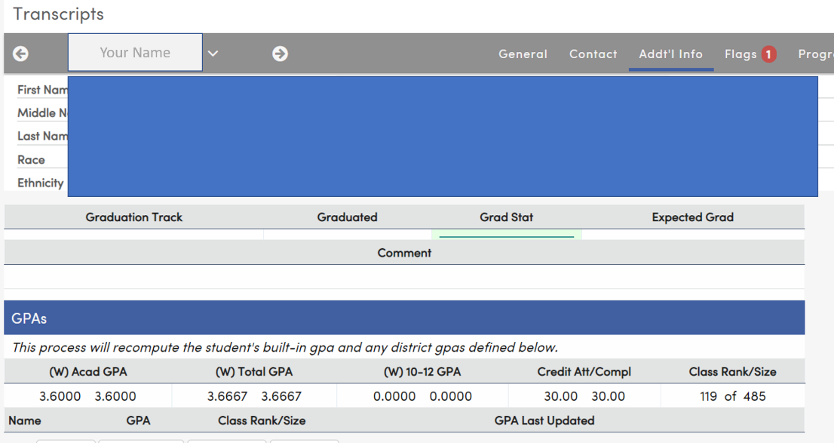replace ex w/ yours

RETURN COMPLETED APPLICATION TO : EMCKAY@TUSD.NET
ON OR BEFORE: APRIL 13, 2022

