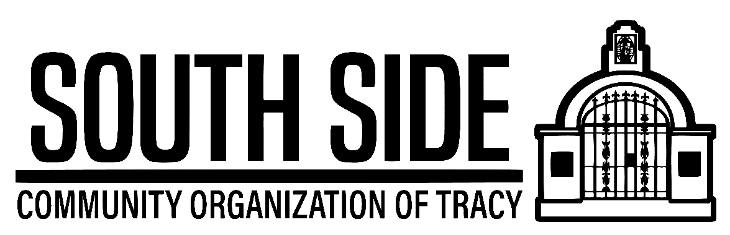
126 W. First Street, Tracy Ca. 95376
2022 SCHOLARSHIP APPLICATION ($500.00)

ELIGIBILITY:
- Must be attending a High School located within the Tracy Unified School District Boundaries.
- Must have an average of 2.0 or 3.0 depending on the categories listed below.
- Students can only apply in one (1) category.
- Must be a high school senior graduate in June 2022
- Must plan to enroll Full Time in a university, community college, state college, and/or vocation/trade school in the fall of 2022.

APPLICATION PROCESS:
- Application available by contacting Anita McManus 209.814.6580
- All questions must be completely answered on the application and the form must be properly filled out.
- Scholarship award is $500.00 and the process involves a written application.
- You may be called for an oral interview if requested by the scholarship panel.
- Applicants will be personally notified of the scholarship outcome.
- Applications must be delivered in person to Anita McManus or mailed to The Guadalupe Center, 126 W. First Street, Tracy Ca. 95376. Attn: Anita McManus no later than 4/22/2022

FORMAT/DOCUMENTATION:
- Application must have a cover sheet with the student’s name, school and category.
- Completed Scholarship Application including responses to all questions.
- Transcript copy, report card, or other proof of grade point average, G.P.A.
- List any community service if any, including location, hours and type of service.

AWARD PRESENTATIONS: The selected scholarship recipients will be notified of the award by phone, in writing and/or via email. You will also be notified when the scholarship will be presented.

DISBURSEMENT: Awards will be disbursed directly to the student upon verification of high school graduation and verification of full time (12 units) college enrollment for the fall of 2022.

APPLICATIONS MUST BE RECEIVED BY MONDAY APRIL 22,2022
For more information contact Anita McManus 209.814.6580

THE SOUTH SIDE COMMUNITY ORGANIZATION OF TRACY
126 W. SOUTH STREET, TRACY CA. 95376
2022 SCHOLARSHIP APPLICATION

The South Side Community Organization of Tracy was founded in 2009 and has a desire to promote the successes of our local youth.

MISSION STATEMENT: The role of our neighborhood organization is to evolve to meet the needs of this community and all residents of Tracy California. Our primary mission is to serve the community’s general welfare through education, economic and cultural development.

ACADEMIC ACHIEVEMENT: Students with a grade point average of (3.0 G.P.A.) and above are eligible.

VISUAL AND PERFORMING ARTS: Students who are involved in various forms of ongoing artistic education including but not limited to visual arts, performing arts (Drama/Voice/Music, graphic arts and media) are eligible. Student must demonstrate a portfolio, tape etc… An overall G.P.A. of 2.0 is required.

VOCATIONAL/TRADE: Student who will be enrolling in vocation training and/or business schools are eligible. An overall G.P.A. of 2.0 is required.

COMMUNITY SERVICE: Students must list what community service or activities they have been involved in over the past four years and have completed a minimum of 200 hours for the Tracy community and Tracy school causes. G.P.A. of 2.0 is required. PLEASE LIST HOW MANY COMMUNITY SERVICE HOURS YOU HAVE COMPLETED AND WHERE.

HEALTH AND SCIENCE: Available to students who are pursuing a career in medicine and/or science. An overall G.P.A. of 3.0 is required.

APPLICATIONS MUST BE RECEIVED BY APRIL 22, 2022

THE SOUTH SIDE COMMUNITY ORGANIZATION OF TRACY
126 W. SOUTH STREET, TRACY CA. 95376
2022 SCHOLARSHIP APPLICATION

Applicant’s legal name _________________________________ School __________________________

Home Address _________________________________City_____________ Zip____________________

Cell Number______________ Secondary number __________________E-mail_____________________

Name of Father or Guardian__________________________ Occupation__________________________

Name of Mother or Guardian_________________________ Occupation__________________________

Check the 1 scholarship you qualify for: Academic Visual/Performing Arts

Vocational/Trade Community Service Health and Science

ON A SPERATE SHEET OF PAPER, PLEASE ANSWER THE FOLLOWING QUESTIONS:

- What are your future educational and career goals, and how do you plan to accomplish
them?
- Please explain why you qualify for the scholarship award in the category you are applying for?
- How do you envision yourself giving back to the community?
- List the post-secondary schools you have applied to?
- What recognitions or awards have you received and which one means the most to you?
- What I.B. Classes have you taken if any?

REMEMBER TO:

- Present the application in a professional manner, either typed or written neatly no later than
April 22, 2022 to: SSCO, 126 W. First Street. Tracy Ca. 95376, mail or drop in mailbox.

- If you are writing, please make sure that your penmanship is legible.

- If you are typing your response, please use a size 12 font and set your line to 1.5 with 1.5 inch margins.

- Attach a certified copy of your school transcript showing proof of your G.P.A.

- Most important, DO YOUR VERY BEST IN ALL YOU DO.

